94.08.00b
To the Gardeners' Chronicle

[Our illustration (fig. 46) is taken from a glass negative prepared in New Guinea by the Rev. Mr. Kennedy, and forwarded by Baron Sir Ferdinand von Mueller. Ed.]

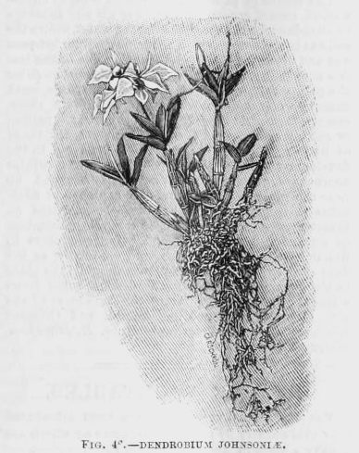

Letter not found. The text given here is from Gardeners' chronicle, 22 September 1894, p. 339. The letter is dated to early August as the latest likely date that it could have been sent for the illustration to have been engraved and published in this issue of the journal.
The illustration 94-08-00b_image01.jpg is in an unsigned article, 'Orchid notes and gleanings'.
C. E Kennedy in 1894 supplied some specimens from Papua to M, e.g. MEL 0577708, recorded as from Milne Bay, the area where his last lay missionary posting, Taupota, was situated (Langmore (1981), p. 433).

